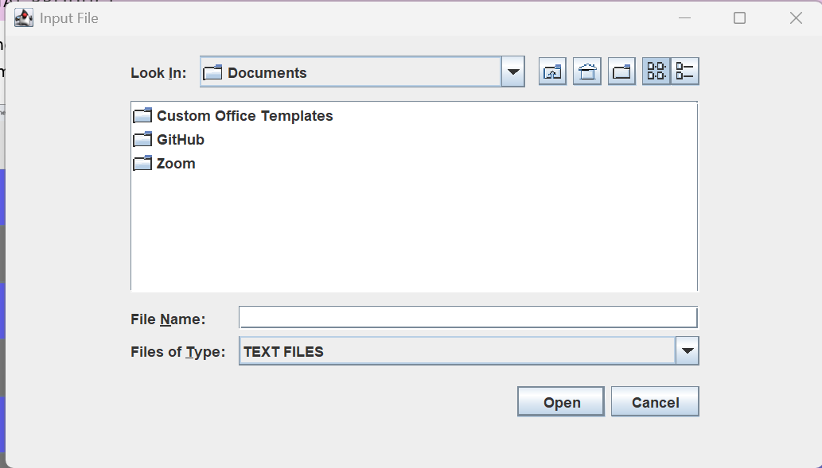
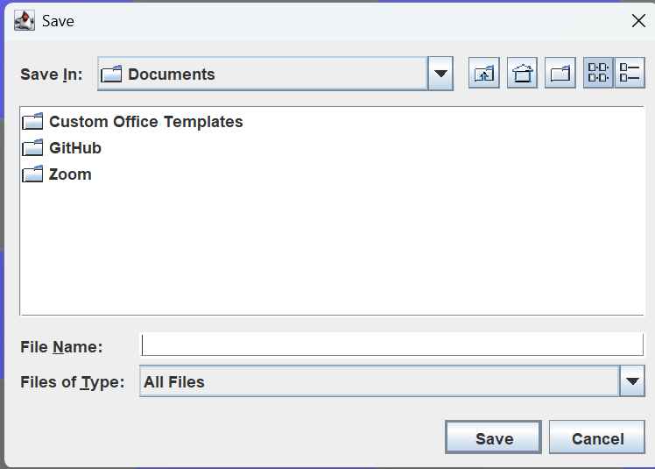
This is the Folder that the user is currently in. The user can click this window to get a drop-down menu to select the folder the user wants to go into.
This area shows what folders are in the area the user is in. The user can double click a file to go into it.
This area shows what folders are in the area the user is in. The user can double click a file to go into it.
Pressed so the user can trigger the file to be saved.
This is the filter for the files so the user can only see and select text files and folders.
Pressed so the user can trigger the file to be open.
The user can type the name of the file they want it to be saved as and the .txt extension will be added to it.
Used to close the window safely if the user opens this menu by accident
Used to close the window safely if the user opens this menu by accident
The user can type the name of the file they want it to be saved as and the .txt extension will be added to it.
This is the Folder that the user is currently in. The user can click this window to get a drop-down menu to select the folder the user wants to go into.
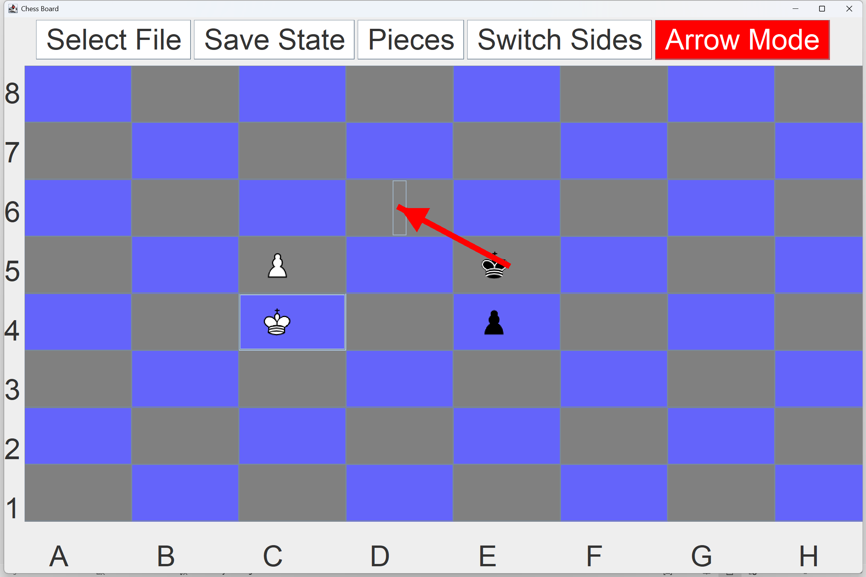
These will open the windows to save and select the file when clicked.
This will open the menu with the pieces for the user to select
This is the arrow made from arrow mode. Its easily visible. You can also see the pieces which are show as pictures loaded from pngs and the board which is made from a 2D array of JButtons
These are the sides of the board that are easily flipped when you hit flip button.
This will switch the sides of the board by flipping the board in the x=y axis and the y = -x + 7 axis so the board is fully flipped, and it will flip the numbers and letters
This enables arrow mode and when active it turns the button red and you can draw the arrow by selecting the squares on the board
Closses the window and all the other windows
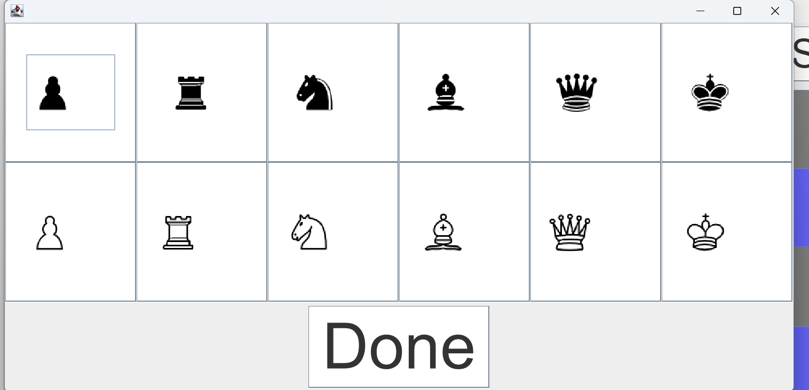
These are the buttons with the pieces in them. When the user clicks the buttons then the piece the button on is selected and then the user clicks a square on the board and that piece that was selected will also be at the square selected by the user.
This will NOT close the window but bring it back to its default form as the done button needs to be clicked so the board is set back to be used safety
This will close the window and stop the board from not being able to move.

